**What is cross media ownership?**

Cross media ownership is the ownership of multiple types of media companies by a person or single corporation. Types of media can include, but not limited to: print, music, electronics television and internet media sites. This allows the company to diversify within multiple media areas and increase profit.

What are the benefits of cross media ownership?

The benefits of cross media ownership:

* Reduced costs - Big companies have more purchasing power
* Synergy - Synergy means self-advertisement. Utilise sister companies, in order to self-advertise which reduce the cost of advertising.
* Wider Distribution - This means the company can increase brand awareness and advertise to different demographics when they buy smaller/multiple media companies

**Examples of Cross Media Companies**

Below are two examples of cross media ownership.

**Sony Corporation**



Sony is a Japanese multinational company based in Japan, founded in 1946.

Sony Corporation is the electronic business company and the parent company of Sony Group. Originally, Sony focused on electronics with the Tape recorder G-type, Japan's first tape recorder. This was the first instrumental product that launched Sony into the electronics industry. Since 1946, Sony has had many successful electronic products (see below) and continued to expand across multiple media.

[caption id="attachment_30" align="aligncenter" width="791"]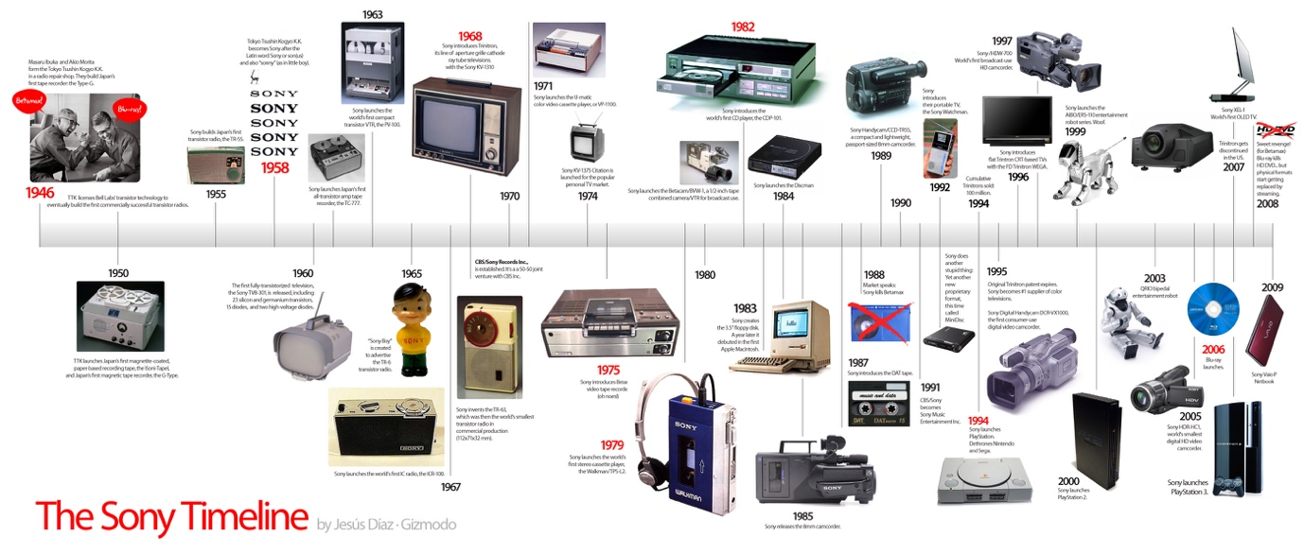Sony Electronics Product Timeline. Reference (<https://gizmodo.com/5485809/the-sony-timeline-birth-rise-and-decadence>)[/caption]

Sony Corporation has now diversified their business into the following areas:

* Sony Picture Entertainment (film production)
* Sony Interactive Entertainment (publishes video games and manufactures video game consoles)
* Sony Music Entertainment (record labels)
* Sony Mobile Communications (multinational mobile phone manufacturer)
* Sony/ATV Music Publishing (other music businesses)
* Sony Financial services (holding copy for Sony's financial services)

During 1990s - early 2000s as a result of their new PlayStation line, Sony experienced massive success. By diversifying across cross media platforms this has allowed Sony to become the largest Japanese corporation by revenue.

**AT&T**

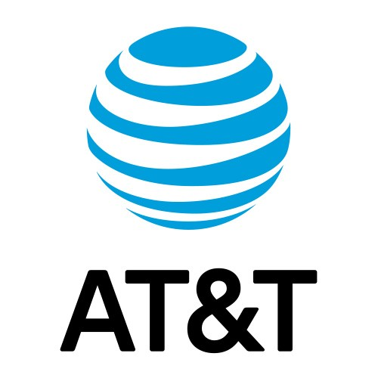

AT&T is the world's largest telecommunication company based in American, found in 1812. The company has diversified into the media industry after becoming the parent company of mass media Warner Media (also known as Time Warner), thus making it the largest media and entertainment company.

Acquiring Warner Media, transformed AT&T to become a cross media company in films, television, cable networks and publishing organisations:

* HBO (Home Box Office Inc)
* Turner Broadcasting System - This includes, but not limited to CNN, Cartoon Network, Turner Sports.
* Warner Bros. Entertainment - This includes Warner Bros. Picture Group, Warner Bros. Television Group, Warner Bros. Home Entertainment Group.

This has increased brand awareness and provided AT&T and Warner Media the opportunity to distribute to a wider audience, improve job prospects e.g. employers have a better opportunity to move across different businesses and increase brand awareness for both AT&T and Warner Media (see below image).

[caption id="attachment_32" align="aligncenter" width="946"]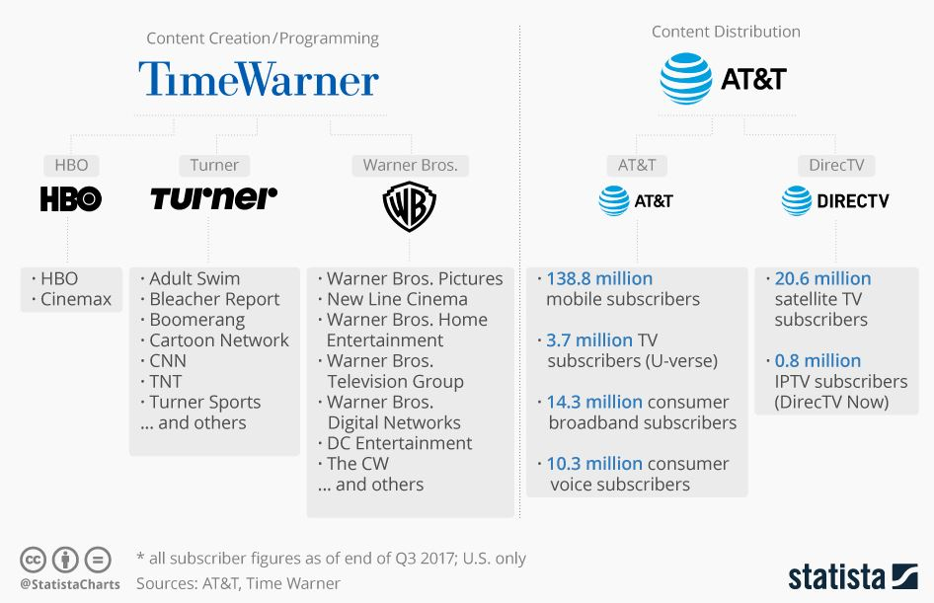Time Warner and AT&T infographic which shows the benefits of merging the two companies. Reference: [(https://www.statista.com/chart/11932/time-warner-and-att-merger/)](https://www.statista.com/chart/11932/time-warner-and-att-merger/)[/caption]